A Two Pronged Approach to Understanding the Role of Convection and Turbulence in Hurricane Dynamics: Airborne Doppler Radar and Numerical Simulation

Steve Guimond

Abstract

The physics of tropical cyclones (TCs) are complex and involve coupled interactions among a wide range of scales. While the synoptic scales are understood relatively well and the vortex scales are becoming better observed, our current understanding and observation of the convective and turbulent scales are lacking. From an observational viewpoint, high-resolution, three-dimensional Doppler radar observations of convection and turbulence in TCs are sparse and current retrievals of the vertical component of the wind and latent heating can contain significant error. From a theoretical viewpoint, the rapid intensification of a TC is sensitive to turbulent momentum fluxes at the eyewall interface, which are not explicitly resolved in numerical model simulations at resolutions most often used by the scientific community (1 – 2 km).
The proposed research will take advantage of new and existing NASA airborne Doppler radars as well as NASA supercomputers to document and address the fundamental problems associated with the convective and turbulent scales in TCs noted above. Specifically, we believe the new, high-resolution, dual-frequency, dual-beam High-altitude Imaging Wind and Rain Airborne Profiler (HIWRAP) for the Global Hawk UAS will improve retrievals of the three wind components and latent heating while assisting in the documentation of turbulence.
In addition, large eddy numerical simulations at 50 – 100 meter resolution will allow TC dynamics, forced by the radar observations of convection, to be studied in a turbulent regime. Calculations with the model data will enable important questions related to the transfer of energy during intensification to be answered with applications for the optimal sampling of convection and TCs from suborbital or spaceborne platforms.
1. Statement of problem
Tropical cyclones (TCs) can inflict great human suffering and pose a significant risk to the economic security of many nations through their impacts on energy and infrastructure. The primary means of addressing these risks is through forecasts that provide decision makers with timely information on the state of the atmosphere and ocean. Another method of mitigating TC risk is through the design of structures (e.g. building codes) that minimize damage from wind and water. If science cannot find a way to modify the TC or secure regions in their path via a prediction, then efforts to cope with their impacts through engineering solutions are probably the best option.
It is well known within the meteorological community that current TC intensity and structure forecasts contain large uncertainty with little improvement relative to forecasts of track over the past 20 – 30 years (DeMaria et al. 2005). An integral part of the forecasting and coping strategies for mitigating TC related risk is the understanding of the physical mechanisms governing storm evolution. Although significant strides have been made in our understanding of the TC, several issues still impede our ability to advance the science of TC forecasting including:
- lack of observations spanning the storm lifecycle, especially those on the scales of convection and turbulence
- incomplete knowledge of the physics on a multitude of scales which can lead to oversimplification of processes in numerical models
- difficulty in solving a system of coupled, non-linear partial differential equations (e.g. numerical approximations in space/time and predictability).

2. Background and relevance to previous work
The main driver of TC genesis, intensity and structure change is the release of latent heat in clouds where the source of moist entropy flux comes from the thermodynamic disequilibrium at the ocean-atmosphere interface (Charney and Eliassen 1964; Kuo 1965; Emanuel 1986). It is believed that integrated cloud heating over the entire volume of the storm is responsible for intensity and structure change (Cecil and Zipser 2003) although realistic modeling studies (Braun 2002) and observational composites (Black et al. 1996) show that small-scale, intense convection (“hot towers”) contribute a large percentage (~ 65 % from updrafts stronger than 2 m s⁻¹) of the total mass transport.
Despite the fundamental importance of latent heat release, little is known of the structure in both space and time within a TC and balanced non-linear models describing the storm evolution, show large sensitivity to the structural characteristics of the heating (Hack and Schubert 1986). Most observational estimates of latent heat are from satellites, which have coarse resolution in both space and time. Thus, the eyewall regions of a TC with embedded hot towers are poorly resolved leading to large errors in the latent heating field.
As part of the author’s dissertation, a new latent heat retrieval method was developed and applied to NOAA WP-3D airborne Doppler radar data collected in rapidly intensifying Hurricane Guillermo (1997) at a spatial resolution of 2 km in the horizontal and 1 km in the vertical (Guimond and Reasor 2009). Figure 1 shows three-dimensional (3D) snapshots of the retrieved latent heating field revealing deep convective clouds rotating around the eyewall of the storm. Although the retrievals have advanced our knowledge of the structure of latent heating in TCs, several uncertainties remain. Some of these include: uncertainty in radar reflectivity derived parameters, errors in the derived vertical velocities and the relatively coarse resolution (although the resolution was improved over satellite based estimates). The use of a new airborne Doppler radar developed at NASA GSFC (Heymsfield et al. 2007) should help to reduce these uncertainties and allow more accurate retrievals of latent heating. Details will be
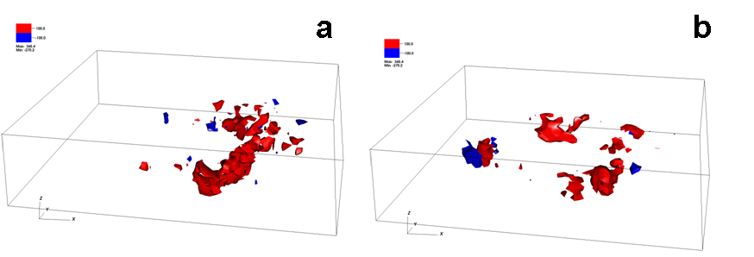
Figure 1. Three-dimensional isosurfaces of the latent heat of condensation/evaporation (K h⁻¹) retrieved from Doppler radar observations in Hurricane Guillermo (1997) at (a) 1855 UTC 2 August and (b) 2225 UTC 2 August. The grid volume is storm-centered extending 120 km on each side and 19 km in the vertical with a grid spacing of 2 km in the horizontal and 1 km in the vertical. Red indicates condensation while blue shows evaporation.

explained in sections 3 and 4.
The full spectrum of latent heating excites two general classes of dynamical modes in the TC relative to the storm center: axisymmetric and asymmetric (departures from axisymmetry). Although the wind and vorticity fields of a TC are highly axisymmetric (Reasor et al. 2000), the distribution of convection and latent heating is often asymmetric with seemingly disorganized variations in time. Axisymmetric theories for TC evolution such as the Wind Induced Surface Heat Exchange (WISHE) mechanism focus on mean structure (Emanuel 1986). In the WISHE model, boundary layer radial inflow to the storm center acquires moist entropy from the underlying warm ocean and through frictional convergence at the sea surface, deposits this energy aloft where it can power the storm to generate stronger winds. The air is then expelled outward far from the storm center where it sinks and can start the cycle over again (Emanuel 1986). While considerable insight has been gained from the WISHE model, asymmetries such as eddy angular momentum fluxes, vortex Rossby waves, potential vorticity mixing, mesovortices and vortical hot towers have been shown to be integral to TC intensity and structure change (Montgomery and Kallenbach 1997; Schubert et al. 1999; Montgomery et al. 2006) yet they can only be parameterized in axisymmetric theory because the model is fundamentally two-dimensional.
Many of the mechanics behind TC structure and intensity change outlined above either rely on or are sensitive to turbulent properties of the flow. For example, Emanuel (1997) described the eyewall of a TC as an atmospheric front where the frictionally induced inflow concentrates moist entropy inside the radius of maximum winds (RMW) leading to strong radial gradients in angular momentum. In order for enhanced periods of intensification to occur (rapid intensification) in the WISHE model, mechanical spin-up of the eye by radial turbulent fluxes of angular momentum (asymmetries) from the eyewall is necessary to invigorate the energy cycle. However, little is known of the structure of turbulence in TCs and its role in the 3D evolution of the storm (Bryan and Rotunno 2009). As noted above, most airborne Doppler radar observational analyses (such as those from the NOAA WP-3Ds) are 2 km in the horizontal and 1 km in the vertical (Reasor et al. 2009), which is likely insufficient to resolve turbulent eddies. Furthermore, exploratory numerical simulations at turbulence resolving scales (on the order of 100 meters or less) are only beginning to be conducted (Rotunno et al. 2009).
It is clear that many unknowns exist in our knowledge of convection, latent heating and turbulence and their role in TC dynamics. My proposed research at NASA will address these unknowns by utilizing new and existing NASA high resolution Doppler radar observations and numerical simulations performed on NASA supercomputers. Now is the time to capitalize on these unique NASA resources (including upcoming field experiments) that may lead to significant progress in our understanding (and forecasting) of the TC. Details of the research plan are presented in the next section.

3. General methodology and procedure
The proposed work involves two main areas to understand the physics of TCs better: observational analysis and numerical simulation. The goal of the observational analysis will be on improving the retrieval of latent heat and the documentation of turbulence structure with two NASA GSFC airborne radars, the ER-2 Doppler radar (EDOP) (Heymsfield et al. 1996) and the new High-altitude Imaging Wind and Rain Airborne Profiler (HIWRAP; Heymsfield et al. 2007). The primary focus will be on HIWRAP data, which will be collected in summer 2010 during NASA’s Genesis and Rapid Intensification Processes (GRIP) field campaign (if this proposal is selected, I would be honored and excited to participate in GRIP). To support the radar analyses, in situ measurements (dropsondes) and other remote sensing observations will be used from GRIP similar to a paper published from a previous NASA field experiment (Guimond et al. 2010). However, if unfavorable environmental conditions prevent the sampling of TCs, EDOP data collected in several previous NASA field campaigns will become the primary focus for the characterization of turbulence.
Figure 2 shows EDOP observations of a vigorous hot tower in the eyewall of Hurricane Dennis (2005) during a rapid deepening phase of the storm (Guimond et al. 2010). The EDOP uses a unique nadir and forward pointing antenna system at a frequency of 9.6 GHz from the high-altitude (20 km) ER-2 aircraft providing 100 m along-track and 37.5 m vertical sampling that enables turbulent features of TCs and hot towers to be captured. The detailed structure of the eyewall of Dennis can be seen in Fig. 2 including broad, strong pulses of upward/downward motion near 12 km height (Fig. 2a) and radial turbulent eddies that are transporting angular momentum into the eye of the storm (Fig. 2b). The horizontal and vertical scales of many of these features are less than 2 km, which may not be resolved by other airborne radars such as the NOAA WP-3Ds as
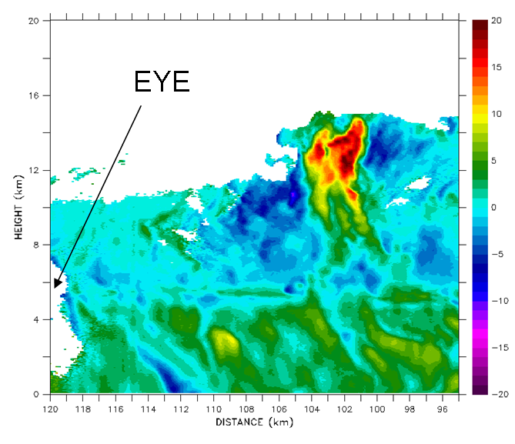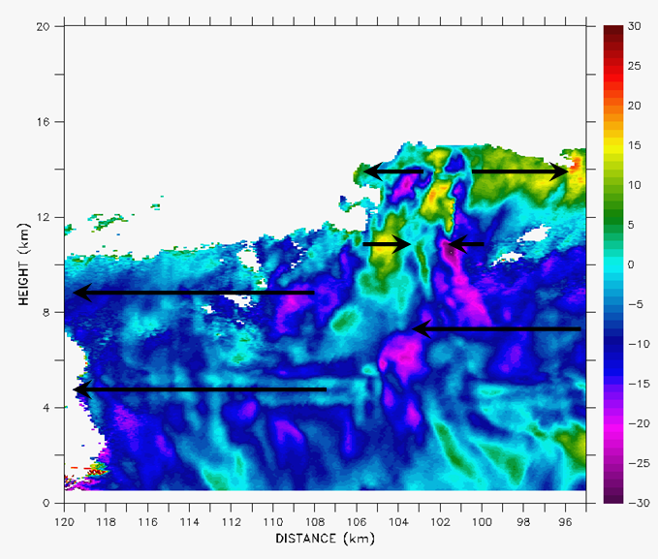 Figure. 2. Vertical cross sections of EDOP retrieved (a) vertical velocities (m s⁻¹) and (b) storm-relative radial velocities ( m s⁻¹) in the eyewall of Hurricane Dennis (2005) at ~ 1500 UTC 9 July 2005 during a rapid intensification episode. The hot tower is centered around 102 km along the horizontal axis.
a
b

well as numerical simulations with 1 – 2 km horizontal grid spacing. One of the drawbacks of the EDOP system is the inability to measure the three wind components (due to the non-scanning antenna) as well as the 3D structure of precipitation features. However, the HIWRAP system is able to determine these essential components and should provide substantial insight into the turbulent structure of TCs and convection.
The HIWRAP system is a conically scanning airborne Doppler radar designed to fly on the high-altitude (20 km) Global Hawk UAS with two simultaneous beams (incidence angles of 30° and 40°) each operating at both Ku and Ka band. The Ku and Ka band frequencies allow for greater sensitivity to non-precipitating cloud particles in addition to providing information on precipitating hydrometeors including the drop-size distribution. The dual-beam, dual-frequency measurements at different azimuthal angles provide many independent measurements of the radial component of the wind within a high-resolution analysis volume of 1 km x 1 km x 60 m, allowing for improved accuracy in the retrieval of the three wind components (especially vertical velocity) compared to current airborne radars (Ray et al. 1978; Heymsfield et al. 2007). In addition, the Ku band frequencies of HIWRAP allow the estimation of surface winds (similar to NASA’s QuikSCAT satellite), which will assist in characterizing the wind field in the storm from the sea surface to the cloud top at high resolution (never been done before from a single instrument). Based on the features of the HIWRAP instrument described above and the long (30 h) flight times of the Global Hawk aircraft, we expect unprecedented, exciting and useful observations to be obtained in the TC providing invaluable information for the retrieval of latent heating and characterization of the turbulent structures in convection.
The second aspect of the proposed work is to conduct numerical simulations of TCs at turbulence resolving scales (50 – 100 meters in the horizontal and vertical; Bryan et al. 2003). Although the structure in Fig. 2 is interesting, it is not clear how the basic physics of TC intensification in three-dimensions will change by accounting for the turbulent details that high-resolution instruments provide. In order to understand the physics, preliminary numerical simulations using a fully compressible, non-linear atmospheric model (HIgh GRADient applications model or HIGRAD; Reisner et al. 2005) developed at Los Alamos National Laboratory (LANL) along with hot tower perturbations using EDOP data have been conducted as part of my dissertation work. In this idealized work, the model atmosphere is dry with a domain extending 1,024 km on a side including a 70 km square region in the center with constant 200 m resolution stretching to 2 km at the boundaries. The initial vortex is axisymmetric, quasi-balanced and of hurricane strength. A pulse of heating derived using EDOP observations is placed in the model at 25 km radius, just inside the RMW of the vortex and held constant in time. An identical simulation to the one above only using 1 km resolution in the interior was also performed to highlight differences in the evolving structure due to turbulence and grid spacing. If my proposal is accepted, I plan on applying for time on NASA supercomputers (Pleiades and/or Columbia) with additional computer support possible from LANL that will allow for efficient progress on the numerical simulation project goals.

Figure 3 shows vertical velocity at 10 km height in the core of the vortex 1 h into the simulation from both the 1 km and 200 meter cases. In the 1 km simulation (Fig. 3a), a spiral gravity wave emanating from the heating pulse is clearly visible as the atmosphere

adjusts toward a state of balance. At the same time in the 200 m simulation (Fig. 3b), the structure of the gravity waves are vastly different as the flow has developed into discrete turbulent eddies with larger amplitudes when compared to the 1 km case. Based on the structure of the gravity waves in Fig. 3, the balanced adjustment process and transfer of energy from the perturbations (convection) to the basic state vortex is expected to be quite different in a turbulent regime.
Specific questions to be addressed by the modeling work include: (1) how does the structure and role of asymmetric processes change as turbulence becomes explicitly
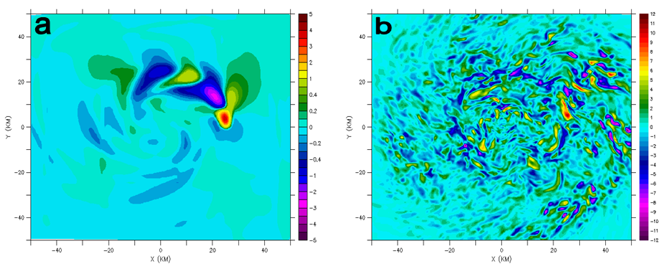Figure 3. Horizontal cross sections of vertical velocity in the inner core of the simulated vortex at 10 km height after 1 h of simulation using a heating pulse derived from EDOP data (a) 1 km horizontal resolution and (b) 200 m horizontal resolution.

resolved and (2) what scales of convective heating is the TC most efficient at converting to wind energy and how does the balanced adjustment process, including energetics, change in a turbulent regime? Much of the energy introduced through convective heating will be radiated away through gravity waves, yet it is unclear if the adjustment process and retention of balanced kinetic energy in TCs is dependent on the scale of the convective disturbance and turbulent effects. The simulations will start at ~ 1 km horizontal resolution and extend down to ~ 50 m to test the sensitivity in the computed energy exchanges between the perturbations and the basic state vortex. Furthermore, the 50 meter simulations will be used to support preliminary wind retrieval tests with HIWRAP and other NASA airborne Doppler radars in development such as the ER-2 X band Radar (EXRAD).

4. Expected results and significance
The expected results from the observational component of the proposal are:
- improvements in the retrieval of latent heating using HIWRAP observations
The HIWRAP system will enable the achievement of this goal through (a) more accurate diagnosis of water content parameters using the dual-frequency measurements, (b) increased accuracy in the retrieval of the three wind components (especially vertical velocity; a very important parameter in the estimation of latent heating) as a result of the increased sensitivity and the dual-beam approach and (c) higher horizontal and vertical resolution compared to some existing airborne radars.
Given the fact that latent heating is the driving force behind many atmospheric circulations including TCs, improved estimates from HIWRAP are quite significant for the atmospheric science community and NASA objectives. Furthermore, NASA’s Global Precipitation Measurement (GPM) mission will employ the same frequencies as HIWRAP in a similar downward viewing geometry allowing preliminary latent heating algorithm development and testing to be completed before the satellite reaches orbit.
- quantitative characterization of turbulence (length scales, magnitudes) in TCs using both EDOP and HIWRAP data.
As mentioned in section 2, the current knowledge of turbulence structures in TCs is lacking yet several theories describing the physics of intensification are sensitive to their properties. Examining EDOP and HIWRAP data for turbulent structures such as those shown in Fig. 2b will allow for the development of parameterizations to be used by coarse resolution operational numerical models and validation for higher resolution simulations.
The expected results from the turbulence resolving (50 – 100 meters), numerical modeling component of the proposal are:
- quantification on the role of asymmetric TC dynamics in a turbulent regime through diagnosis and calculation of model output.
- documentation of the scales that minimize the sensitivity in the TC’s balanced response (adjustment process) to convective heat sources.
Based on the work of Bryan and Rotunno (2009) using an axisymmetric model and preliminary results from my dissertation using a 3D model, the role of the asymmetric mode can change based on uncertain aspects of the turbulence parameterization. In conjunction with the observational documentation of turbulence, large eddy simulations at 50 – 100 meter resolution will remove much of the uncertainty due to turbulence parameterizations and allow for a clearer interpretation on the role of the asymmetric mode in TC dynamics.
Potential applications of the modeling work include motivation for current and future satellite/aircraft remote sensors of convection and TCs. If the research from the proposal confirms an important impact from purely asymmetric processes, then observations would need to sample those asymmetries instead of simply relying on the azimuthal average structure. In addition, if the TC response to convective heat sources and the exchanges of energy are sensitive to resolutions at scales much less than 1 – 2 km (a typical grid spacing of observational analyses and model simulations of TCs), then remote sensing networks would need to increase their resolution in order to maximize the value of the measurement.

REFERENCES
Black, M.L., R.W. Burpee, and F.D. Marks, Jr., 1996. J. Atmos. Sci., 53, 1887-1909.
Braun, S.A., 2002. Mon. Wea. Rev., 130, 1573-1592.
Bryan, G.H., and R. Rotunno, 2009. Mon. Wea. Rev., 137, 1770-1789.
Bryan, G.H., J.C. Wyngaard, and J.M. Fritsch, 2003. Mon. Wea. Rev., 131, 2394-2416.
Cecil, D.J., and E.J. Zipser, 1999. Mon. Wea. Rev., 127, 103-123.
Charney, J.G., and A. Eliassen, 1964. J. Atmos. Sci., 21, 68-75.
DeMaria, M., M. Mainelli, L. K. Shay, J. A. Knaff, and J. Kaplan, 2005. Wea.
Forecasting., 20, 531-543.
Emanuel, K.A., 1997. J. Atmos. Sci., 54, 1014-1026.
Emanuel, K.A., 1986. J. Atmos. Sci., 43, 2044-2061.
Guimond, S.R., G.M. Heymsfield, and F.J. Turk, 2010. J. Atmos. Sci., In press.
Guimond, S.R., and P.D. Reasor, 2009. Preprints, 34th Conf. on Radar Meteorology,
Williamsburg, VA, American Meteorological Society.
Hack, J.J., and W.H. Schubert, 1986. J. Atmos. Sci., 43, 1559-1573.
Heymsfield, G.M., and Coauthors, 1996. J. Atmos. Oceanic Technol., 13, 795-809.
Heymsfield, G., J. Carswell, L. Li, D. Schaubert, and J. Creticos, 2007. NASA Science
Technology Conference, College Park, MD.
(see http://esto.nasa.gov/conferences/nstc2007/papers/Carswell_James_B5P2_NSTC-07-
0085.pdf)
Kuo, H.L., 1965. J. Atmos. Sci., 22, 40-63.
Montgomery, M.T., M.E. Nicholls, T.A. Cram and A. Saunders, 2006. J. Atmos. Sci., 63,
355-386.
Montgomery M. T., and R. J. Kallenbach, 1997. Quart. J. Roy. Meteor. Soc., 123, 435-
465.
Ray, P.S., K.K. Wagner, K.W. Johnson, J.J. Stephens, W.C. Bumgarner, and E.A.
Mueller, 1978. J. Appl. Meteor., 17, 1201-1212.
Reasor, P.D., M.D. Eastin, and J.F. Gamache, 2009. Mon. Wea. Rev., 137, 603-631.
Reasor, P.D., M.T. Montgomery, F.D. Marks, Jr., and J.F. Gamache, 2000. Mon. Wea.
Rev., 128, 1653-1680.
Reisner, J.M., V.A. Mousseau, A.A. Wyszogrodzki, and D.A. Knoll, 2005. Mon. Wea.
Rev., 133, 1003-1022.
Rotunno, R., Y. Chen, W. Wang, C. Davis, J. Dudhia, and G.J. Holland, 2009. Bull.
Amer. Meteor. Soc., 90, 1783-1788.
Schubert, W.H., M. T. Montgomery, R. K. Taft, T. A. Guinn, S. R. Fulton, J. P. Kossin,
and J. P. Edwards, 1999. J. Atmos. Sci., 56, 1197–1223.

